THEORY QUESTIONS
1.
(a)

Study the simple circuit diagram shown below and answer the questions that follow.
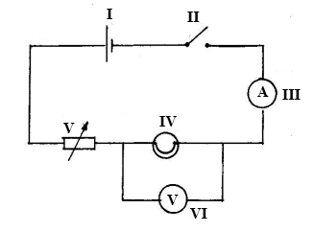
(i)

Identify the components labelled I, II, III, IV, V and VI
(ii)

Which component is used to close the circuit?
(iii)

State the observation that will be made when the circuit is closed.
(iv)

State the energy transformations that take place when the circuit is closed
(v)

Give the name of the circuit connection between components IV and VI
(b)

The diagram below is an illustration of an experimental set-up used for separating a mixture of water and alcohol. Study the diagram carefully and answer the questions that follow.
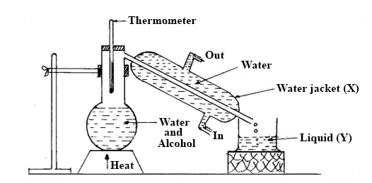
(i)

State the method of separation shown in the set-up.
(ii)

Identify liquid Y, with reasons.
(iii)

Give the functions of the thermometer and the water jacket X
(iv)

What physical processes are involved in the method of separating the mixture?
(v)

State the physical property which makes it possible to separate the water and alcohol.
(c)

A student performed tests on food substances A, B and C and made the following observations
Food substance | Test | Observation
A | Few drops of iodine solution was added to A | The iodine solution turns blue-black
B | A drop of B was applied to a white sheet of paper | A translucent patch was seen on the paper
C | Benedict's solution was added to C and the mixture boiled | Benedicts's solution turns from blue to brick-red
(i)

Identify food substances A, B and C.
(ii)

Give the products of digestion of A, B and C
(iii)

In which parts of the alimentary canal does the digestion of each of food substances A, B and C start?
(iv)

In which part of the alimentary canal is food substance C absorbed after digestion?

2.
a)

i)

List four parts of a plant that are used for asexual reproduction.
ii)

Give two reasons why sexual reproduction is more advantageous than asexual reproduction.
b)

i)

Explain why atoms are electrically neutral.
ii)

Write the systematic names of the following substances:
α)

CuO
β)

SO₂
c)

i)

What is dispersion of light?
ii)

Draw and label a diagram of dispersion of light through a triangular glass prism.

3.
a)

i)

What is soil erosion?
ii)

Give two types of soil erosion.
b)

Write the name and chemical formula of the compounds formed when the following elements combine:
i)

zinc and oxygen
ii)

calcium and chlorine
c)

i)

Distinguish between heat and temperature.
ii)

Draw and label the mercury-in-glass thermometer.
iii)

What mode of heat transfer is involved in the use of a thermometer?

4.
a)

i)

What is a hormone?
ii)

Copy and complete the following table.
Name of hormone | Organ secreting hormone | Function of hormone
Adrenalin
Thyroxin
Insulin
b)

Ammonia gas is prepared in the laboratory by heating ammonium chloride and calcium hydroxide.
i)

Write a balanced equation for the reaction.
ii)

How is ammonia gas tested in the laboratory?
iii)

State one use of ammonia.
c)

i)

Name four types of forces.
ii)

A boy used a catapult to kill a bird which was on a tree and it fell to the ground.
Give two forces involved in this process.

5.
a)

i)

Distinguish between a rhizome and a stem tuber.
ii)

Give one example each of a rhizome and a stem tuber.
b)

State the method which could be use to separate each of the following mixtures and explain your answer in each case:
i)

salt and water;
ii)

sawdust and iron filings;
ii)

powdered charcoal and water.
c)

i)

Define density of a substance.
ii)

Explain how a body which sinks in water could be made to float.

